**GenSec Industries: Requirement Specification document**

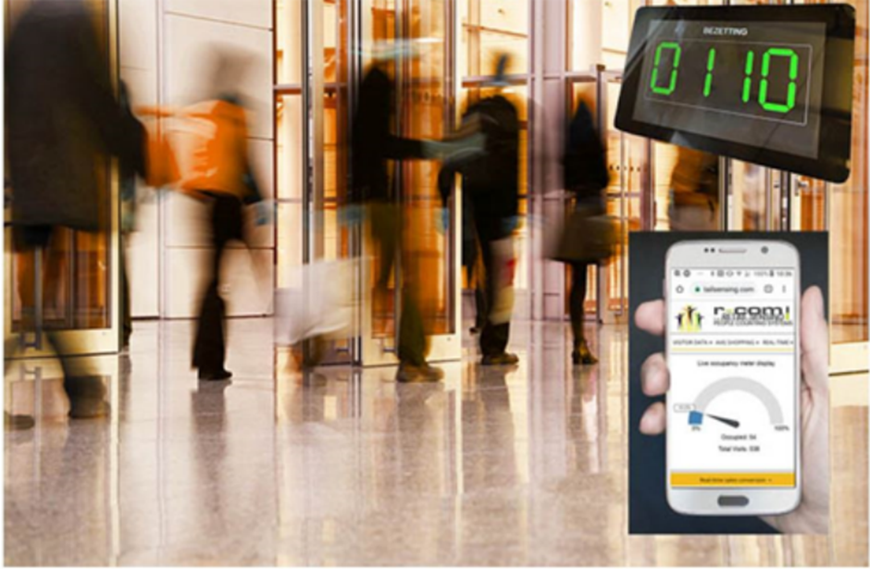  
  
  
  
  
  
  
  
  
  
  
Johnson Domacasse 4471709  
Nedyalko Tenev 4808231  
Tuan Kiet Ho 4832649  
Farros Ramzy 3767353

1. Introduction 2

2. Requirements 3

2.1 User requirements 3

2.2 Functional requirements 3

2.3 Non-functional requirements 4

3. References 4

# Introduction

*The focus of this document is to bring together all the requirement that the occupancy management system needs to comply with. These include the user requirements, the functional requirements, and the non-functional requirements. Some requirements were given to the team by the stakeholders. Others were created to give the system a better functionality.*

# Use Cases

*The following use cases were defined for the system. These use cases will be applied for the user requirements in the next section.*

|  |  |
| --- | --- |
| **Use Case ID:** UC_001 | **Use Case:** Choosing entry line |
| **Description:** | An incoming passenger follows the guide on the “Divider” UI display to choose an entry queue which has low or decent traffic flow. |
| **Pre-Condition:** | * Passenger scans the ticket to the scanner. |
| **Post-Condition:** | * The “Divider” UI displays the queue guide. * The passenger follows the guide to go to the correct queue line. |
| **Actor:** | passenger |

|  |  |
| --- | --- |
| **Use Case ID:** UC_002 | **Use Case:** Entering the Security-Check area |
| **Description:** | A passenger in an entry queue enters the Security-Check area to do a luggage checking procedure before entering the Duty-Free area. |
| **Pre-Condition:** | * The entry gate is closed. * Number of occupancies are not at maximum. * The passenger waits in the queue line before passing the entry gate. |
| **Post-Condition:** | * The entry gate is open. * The passenger enters the Security-Check area. |
| **Actor:** | passenger |

|  |  |
| --- | --- |
| **Use Case ID:** UC_003 | **Use Case:** Entering the Duty-Free area |
| **Description:** | A passenger in the Security-Check Area enters the Duty-Free area after finishing the luggage checking procedure. |
| **Pre-Condition:** | * The Duty-Free entrance is closed. * The passenger finished the luggage checking procedure. |
| **Post-Condition:** | * The Duty-Free entrance is open. * The passenger exits the Security-Check area and enters the Duty-Free room. |
| **Actor:** | passenger |

|  |  |
| --- | --- |
| **Use Case ID:** UC_004 | **Use Case:** Exiting the Security-Check area on Emergency |
| **Description:** | An airport security guard triggers the emergency protocol somewhere to inform people in the airport to leave the building. |
| **Pre-Condition:** | * Alarm trigger is off. * There are people inside the Security-Check & Duty-Free areas. * Active Security-Check entries are closed. * Emergency Exits from the Duty-Free area is closed. |
| **Post-Condition:** | * Alarm trigger is on. * Active Security-Check entries are open. * Emergency Exits from the Duty-Free area is open. * People inside the Security-Check area and its queue are moving back to go to the building safe point through the open Security-Check entries. * People inside the Duty-Free room are moving out from the building using the emergency exit inside the duty-free area. |
| **Actor:** | passengers & security guards |

|  |  |
| --- | --- |
| **Use Case ID:** UC_005 | **Use Case:** Distributing Entry Lines’ Activity |
| **Description:** | If a queue line for an entrance to the Security-Check area is busy, another gate should be active. Therefore, new passengers can go, make a new entrance queue to make the Security-Check procedure efficient. |
| **Pre-Condition:** | * An active queue entry detects that the max queue line is already reached. * A busy signal is being sent to the “Divider”. |
| **Post-Condition:** | * “Divider” activates an inactive gate system if available. * “Divider” tells passengers to go to the line which is not busy to control the queue traffic. * Another security guard do the luggage check duty to the passenger in the new activated gate system. |
| **Actor:** | Passengers & security guards |

# Requirements

*In this section, all requirements relating to the use cases above are listed.*

## User Requirements

*User requirements are typically written when discussing the use cases for a project.* **[1]** *Below you will find the user requirements for the occupancy management system.*

|  |  |  |
| --- | --- | --- |
| **User Requirements ID** | **Description** | **Use Cases ID** |
| **UR_01** | Passengers should be able to see the UI display on the “Divider” system. | UC_001  UC_005 |
| **UR_02** | Passengers should use the UI to be guided to their security lane for the security check. | UC_001  UC_005 |
| **UR_03** | Passengers and their luggage need to move together throughout the process. | UC_003 |
| **UR_04** | Passengers should be able to follow the safety rules of the airport during emergencies. | UC_004 |
| **UR_05** | Security guards should have access to activate or deactivate the emergency alarm manually. | UC_004 |
| **UR_06** | Security guards should be able to recognize the new open entry gate and let an employee do the security-check procedure for the passengers there. | UC_005 |

## 2.2 Functional requirements

*Functional requirements define what a product must do, what its features and functions are.***[2]** *Below you will find the functional requirements for the occupancy management system.*

|  |  |  |
| --- | --- | --- |
| **Functional Requirements ID** | **Description** | **Use Cases ID** |
| **FR_01** | The “Divider” system must be able to scan the passenger’s ticket. | UC_001 |
| **FR_02** | “Divider” system must be able to display the entry queue for the user. | UC_001  UC_005 |
| **FR_03** | “Divider” system must be able to decide the entry traffic, based on communication between all active gates. | UC_001  UC_005 |
| **FR_04** | Gate system must be able to communicate with each other and to the “Divider” system. | UC_005 |
| **FR_05** | Gate system must be able to detect its maximum queue to control the traffic flow of passengers. | UC_001  UC_005 |
| **FR_06** | “Divider” system must be able to communicate with another “Divider” system. | UC_005 |
| **FR_07** | The occupancy management system’s data must be transferred to the database so a maintainer can download it to check the system if needed. It can also serve to display on a UI to be seen by an employee high in command. (OOS) | UC_002  UC_003 |
| **FR_08** | The system should have access to read the alarm trigger of the airport. (OOS) | UC_004 |
| **FR_09** | The alarm trigger should be accessible so that a security guard can trigger an emergency case. | UC_004 |

## 2.3 Non-functional requirements

*Non-functional requirements describe the general properties of a system. They are also known as quality attributes.***[2]** *Below you will find the non-functional requirements for the occupancy management system.*

|  |  |  |  |
| --- | --- | --- | --- |
| **Non-Functional Requirements ID** | **Name** | **Description** | **Use Cases ID** |
| **NFR_01** | Performance | Response time of communication between the Gate Systems to the “Divider” system and each other must be quick. | UC_001  UC_002  UC_003 |
| **NFR_02** | Security | The security-check gate must be closed until a ticket is scanned. The gate will then open to let passengers through and close after. The gate should be a one-way gate (unless emergency case is triggered) | UC_002  UC_003  UC_004 |
| **NFR_03** | Reliability | If one gate disconnected, the system should communicate to decide a solution (either opens a new gate, or divide active lines equally) | UC_001  UC_005 |
| **NFR_04** | Maintainability | The system must notify the user if a malfunction happens, and the system must be extendable and upgradable for future possibilities. | UC_001  UC_002  UC_005 |
| **NFR_05** | Error Handling | The system must display a clear and informative message of error at a malfunction in case of access denial. | UC_001  UC_002  UC_005 |

## 2.4 Concrete scenario

*The concrete scenario is defined so that there is a good foudnation to work upon. The concrete scenario explains use case: UC_002 better by providing this with a sequence diagram. Below you will find the concrete scenario. NOTE: this version has the heartbeat method implemented so that the Divider can keep track of all the “alive” gates.*

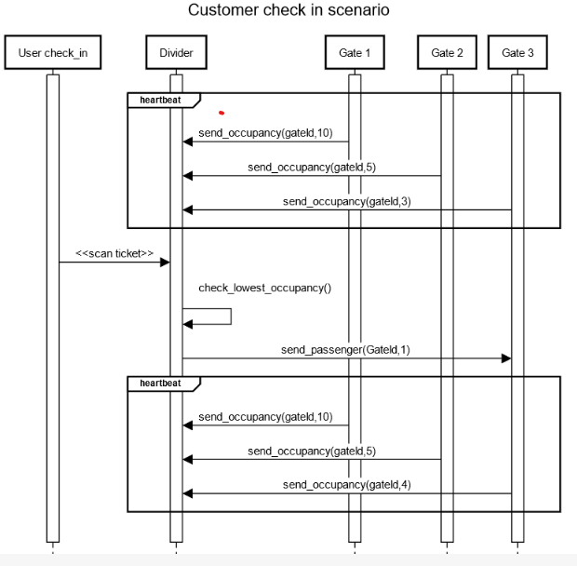

# References

[1] - *User requirement*. User Requirement - an overview | ScienceDirect Topics. (n.d.). <https://www.sciencedirect.com/topics/engineering/user-requirement>

[2] - Editor. (2019, October 18). *Functional and nonfunctional requirements: Specification and types*. AltexSoft. <https://www.altexsoft.com/blog/business/functional-and-non-functional-requirements-specification-and-types/>